GOVERNMENT OF INDIA
Ministry of Commerce & Industry | NICDC
Industrial Corridor Project Management System (IC-PMS)

MODULE 7
Risk Management
ISO 31000 / PMBOK 7 / Primavera Risk Analysis Aligned | Monte Carlo Simulation Engine
Detailed Design Document

Document Version: 1.0 | March 2026 | Classification: Restricted
Prepared by: IC-PMS Solution Architect Team | NICDC / Ministry of Commerce & Industry

1. Module Overview

1.1 Purpose & Objectives
Module 7 — Risk Management — is the proactive intelligence layer of IC-PMS. It systematically identifies, assesses, quantifies, plans responses to, monitors, and reports on the risks and opportunities that could affect the delivery of India's industrial corridor programme. The module is designed to align with the international risk management standard ISO 31000:2018, the PMBOK 7th Edition risk management process, and the quantitative simulation capabilities of Oracle Primavera Risk Analysis — making it the most analytically sophisticated module in IC-PMS.
The module addresses a fundamental challenge in large Indian government infrastructure projects: risks are often identified informally, tracked in spreadsheets, monitored inconsistently, and escalated reactively — after damage has occurred. IC-PMS Module 7 replaces this ad-hoc approach with a structured, data-driven risk management framework that integrates with schedule data (Module 2), satellite monitoring (Module 3), cost forecasts (Module 4), and contract intelligence (Module 5) to provide a comprehensive, continuously updated picture of programme risk exposure.
The Monte Carlo simulation engine embedded in Module 7 — executing 10,000 iterations per simulation run — enables NICDC and Ministry officials to understand not just 'what could go wrong' but 'how likely is it to go wrong and by how much?' The P50 and P80 confidence intervals for cost overrun and schedule delay derived from Monte Carlo analysis are the most credible financial risk disclosures available to programme leadership and lenders.
India-specific risk categories — Land Acquisition, Statutory Clearances (MoEFCC, Forest, CRZ), Contractor Financial Health, Monsoon Impact, Tribal Land (Forest Rights Act), and State Government Interface — are built into the risk category taxonomy, making the module relevant to the specific risk landscape of Indian infrastructure programmes.

1.2 Module Scope
Capability | Included | Standard / Reference
Risk identification — structured interviews, checklists, Delphi | Yes | ISO 31000 / PMBOK 7 Risk Identification
Risk category taxonomy — India-specific (9 categories, 48 sub-types) | Yes | IC-PMS / NICDC Risk Breakdown Structure (RBS)
Qualitative risk assessment — 5×5 probability-impact matrix | Yes | PMBOK / APM Risk Scoring
Risk scoring — Risk Score = Probability × Impact (cost + schedule) | Yes | Primavera Risk Analysis aligned
Risk ownership and accountable party assignment | Yes | RACI model — Owner / Action Owner / Reviewer
Risk response planning (Avoid, Transfer, Mitigate, Accept) | Yes | PMBOK 7 / ISO 31000 Risk Response
Monte Carlo simulation — schedule and cost (10,000+ iterations) | Yes | Oracle Primavera Risk Analysis methodology
P50 / P80 confidence intervals for cost and schedule | Yes | EIA / PMI EVM Risk standards
Sensitivity analysis — Tornado chart (top risk contributors) | Yes | Primavera Risk Analysis output
Risk trigger monitoring and auto-escalation | Yes | IC-PMS Innovation — linked to Module 2/3 data
India-specific risk integration (LA, EC, Tribal land, Monsoon) | Yes | NICDC risk register template
Opportunity register (positive risk identification) | Yes | PMBOK 7 — Opportunities as positive risks
Risk heat map with temporal evolution | Yes | RAG heat map — 5×5 matrix view
Lessons learned register (feed-forward to future projects) | Yes | ISO 21500 / APM learning framework
Risk reporting (monthly to NICDC, quarterly to Ministry) | Yes | NICDC governance reporting framework

1.3 Key Design Principles
- Integrated risk intelligence: Risk scores are not isolated — they are cross-referenced with Module 2 schedule float data, Module 3 satellite anomaly alerts, and Module 4 cost overrun trends to produce a composite, evidence-based risk picture
- India-specific risk taxonomy: The Risk Breakdown Structure (RBS) is built around the nine most impactful risk categories for Indian infrastructure — not generic PMBOK categories — ensuring relevance for DMIC, CBIC, and other corridor teams
- Monte Carlo as the standard: Qualitative risk matrices are useful for prioritisation but insufficient for financial disclosure. P80 cost and schedule estimates from 10,000-iteration Monte Carlo simulations are the standard output for lender and Ministry reporting
- Automatic trigger detection: Module 7 continuously monitors Module 2 (SPI threshold breaches), Module 3 (satellite encroachment alerts), and Module 4 (CPI below 0.85) as automatic risk triggers — removing reliance on manual reporting of bad news
- Opportunity register parity: Opportunities (positive risks) are tracked with equal rigour as threats; NICDC's value engineering savings, faster delivery bonuses, and green infrastructure benefits are documented and monitored
- Lessons learned as institutional knowledge: Every closed risk is analysed for lessons; reusable lessons are tagged and searchable across all future corridor projects — building NICDC's institutional risk intelligence over time

2. Sub-Functions — Detailed Requirements

2.1 Sub-Function 7.1 — Risk Identification
Risk Identification is the process of systematically discovering and documenting all risks that could affect the industrial corridor programme. IC-PMS supports multiple identification techniques and provides structured capture forms that guide risk owners to describe risks with sufficient specificity to enable meaningful assessment and response planning.

Identification Techniques Supported
- Structured risk interview template: Pre-populated question sets by project phase (DPR, Land Acquisition, Tendering, Construction, Commissioning) — PMC and SPV team members complete the template and upload to Module 7; system parses responses and creates draft risk records
- Risk Breakdown Structure (RBS) checklist: The 9-category, 48-sub-type RBS is presented as a checklist during workshops; facilitator records whether each sub-type is applicable and creates risk records for applicable items
- Analogous project risk import: Previous NHAI, NMRC, or corridor project risk registers can be imported as a starting point; system flags which risks are relevant to the current project context
- Assumption and constraint log: Project assumptions (e.g., 'land acquisition will be complete by Q1 2026') and constraints (e.g., 'Ministry approval required before Phase 2 start') are registered; system creates corresponding risks for each assumption that fails
- Satellite trigger-sourced risks: Module 3 anomaly alerts (encroachment, idle zones) automatically generate draft risk records in Module 7 for PMC review — bridging physical site observations with the risk register
- Module 2 schedule risk sourcing: Activities with near-zero float (< 7 days) and poor SPI (< 0.85) automatically generate schedule risk records linked to the relevant WBS activities

India-Specific Risk Breakdown Structure (RBS)
Risk Category | Sub-Types (Examples) | Typical Probability | Typical Impact
Land Acquisition (LA) | LA litigation, holdout landowners, tribal land (FRA), compensation disputes, gazette notification delays | High (0.60–0.85) | Schedule: 6–24 months; Cost: 5–20%
Statutory Clearances | Environmental clearance (MoEFCC), Forest clearance, CRZ notification, AAI NOC, Railways NOC, MOEF PARIVESH delays | High (0.50–0.75) | Schedule: 3–18 months
Contractor Risk | Financial distress, sub-contractor default, key personnel departure, equipment breakdown, insolvency | Medium (0.30–0.60) | Schedule: 30–120 days; Cost: 3–15%
Natural Hazards | Monsoon flooding, cyclone, earthquake (zone-specific), heat wave, cloud burst | High (0.60–0.90) seasonal | Schedule: 14–90 days; Cost: 2–8%
Design & Engineering | DPR inadequacy, unforeseen geotechnical conditions, utility conflicts, design changes | Medium (0.40–0.65) | Cost: 5–20%; Schedule: 30–90 days
Market & Prices | Steel/cement price escalation, diesel price, forex for imported equipment, labour inflation | High (0.65–0.80) | Cost: 3–15%
Regulatory & Compliance | GST disputes, labour law compliance, safety regulations, environmental violations | Low-Medium (0.25–0.50) | Cost: 1–5%; Reputation
Technology & Innovation | New construction technology failure, BIM/digital twin failure, software outages | Low (0.15–0.30) | Schedule: 7–30 days
Geopolitical & Policy | State government change, policy reversal, funding cut, corridor priority change | Very Low–Low (0.05–0.25) | Very High — programme-level

2.2 Sub-Function 7.2 — Qualitative Risk Assessment
Qualitative Risk Assessment assigns probability and impact scores to each identified risk, placing it in the 5×5 probability-impact matrix to determine its Risk Rating (RED/AMBER/GREEN). This is the primary prioritisation tool — it focuses management attention on the risks that matter most.

Probability-Impact Matrix (5×5)
Rating | Probability Range | Probability Score | Description
Very High | > 70% | 5 | Almost certain to occur within the project lifecycle
High | 50–70% | 4 | More likely than not to occur
Medium | 30–50% | 3 | Roughly equal chance of occurring or not
Low | 10–30% | 2 | Unlikely but possible; has occurred on similar projects
Very Low | < 10% | 1 | Rare event; unlikely to occur under normal circumstances

Impact Level | Schedule Impact | Cost Impact | Impact Score
Very High | > 90 days on critical path | > 15% of package cost | 5
High | 30–90 days on critical path | 5–15% of package cost | 4
Medium | 7–30 days on critical path | 2–5% of package cost | 3
Low | < 7 days; non-critical | < 2% of package cost | 2
Very Low | < 2 days; negligible | < 0.5% of package cost | 1

Risk Rating from Score
Risk Score (P×I) | Rating | Colour | Required Action
20–25 | Critical | Deep Red (Crimson) | Immediate NICDC MD / Ministry escalation; emergency response plan within 7 days
12–19 | High Risk | Red | SPV Director weekly review; formal mitigation plan within 14 days
6–11 | Amber Risk | Amber | Monthly PMC monitoring; action plan within 30 days
1–5 | Low Risk | Green | Quarterly review; accepted or monitored by SPV PM

2.3 Sub-Function 7.3 — Quantitative Risk Analysis (Monte Carlo Engine)
The Monte Carlo Engine is the quantitative core of Module 7. It takes the qualitative risk assessments, applies statistical distribution functions to each risk's cost and schedule impact range, simulates 10,000 possible project outcome scenarios, and produces probabilistic confidence intervals — the most credible basis for contingency planning and lender/Ministry disclosure.

Monte Carlo Algorithm
- Risk Input Extraction: For all risks rated AMBER or above in the qualitative assessment, three-point estimates are collected: Optimistic impact (O), Most Likely impact (M), and Pessimistic impact (P) — both for cost (₹ Cr) and schedule (days). These are collected during the risk workshop or by the risk owner directly in Module 7.
- Distribution Fitting: Each risk's three-point estimates are fitted to a statistical distribution. Default: PERT distribution = Beta(4, O, M, P). Alternative: Triangular distribution for risks with symmetric impact. Lognormal for cost escalation risks (positive skew). Distribution parameters stored in D9 (Distribution Params store).
- Correlation Matrix: Many construction risks are correlated — if Land Acquisition stalls, both schedule and cost risks worsen simultaneously. A correlation matrix is built from expert elicitation: each pair of risks assigned a correlation coefficient (–1 to +1). Cholesky decomposition used to generate correlated random variables. Stored in D10.
- Sampling Engine (Latin Hypercube Sampling): 10,000 iterations executed using Latin Hypercube Sampling (LHS) for efficient convergence (faster than pure Monte Carlo). In each iteration, a random sample is drawn from each risk's distribution; correlated samples generated via the correlation matrix. Python SciPy / NumPy backend on NIC MeghRaj GPU cluster.
- Schedule Simulation: Each iteration applies the sampled risk impacts to the project schedule (from Module 2). CPM recalculated for each iteration to compute total schedule delay. Distribution of 10,000 completion date outcomes plotted as S-curve. P50 and P80 completion dates identified.
- Cost Simulation: Each iteration applies sampled cost impacts to the project EAC (from Module 4). Distribution of 10,000 total cost outcomes plotted. P50 and P80 cost estimates identified. Contingency recommendation = P80 cost – Deterministic EAC.
- Sensitivity (Tornado) Analysis: After all iterations, Spearman rank correlation between each risk's sampled values and the total outcome is computed. Risks sorted by absolute correlation coefficient to produce the Tornado chart — ranking risks by their contribution to overall uncertainty.
- Convergence Check: Simulation considered converged when the P50 and P80 values change < 0.5% over the last 1,000 iterations. If not converged after 10,000, system runs additional 5,000-iteration batches (max 3 times). Convergence metric stored in D3.

Monte Carlo Output Summary
Output | Description | How Used
P50 Cost Estimate | 50th percentile of cost distribution — there is a 50% chance the final cost will be at or below this value | Reported to NICDC Finance as the 'expected' cost outcome; used in EAC calculation
P80 Cost Estimate | 80th percentile — 80% confidence the cost will be at or below this value | Recommended contingency planning basis; reported to lenders and Ministry as risk-adjusted cost
P50 Schedule Delay | 50th percentile delay in days from scheduled completion | Used in monthly risk dashboard; informs recovery schedule planning
P80 Schedule Delay | 80th percentile delay — 80% confidence delay will not exceed this value | Used in lender milestone certificate negotiations; NICDC MD approval for schedule provisions
Contingency Recommendation | P80 Cost – Deterministic EAC = recommended additional contingency provision | Input to budget management (Module 4) for contingency adequacy assessment
Tornado Chart | Top 10 risks ranked by contribution to cost/schedule uncertainty (Spearman rank correlation) | Identifies which risks deserve the most mitigation investment; key input to response planning
S-Curve (Cost & Schedule) | Cumulative probability distribution for total cost and completion date | Visual tool for stakeholder communication — 'what is the probability of finishing on budget?'

2.4 Sub-Function 7.4 — Risk Response Planning
Risk Response Planning assigns specific actions to reduce, transfer, or accept each identified risk. A well-structured response plan transforms a risk register from a passive documentation exercise into an active management tool — with named owners, clear actions, due dates, and measurable effectiveness criteria.

Response Strategy Types
Strategy | Definition | When to Use | Expected Outcome
Avoid | Eliminate the risk by changing the project approach, scope, or sequence to sidestep the cause entirely | When the risk probability or impact is unacceptably high and an alternative approach is feasible | Reduces probability to near zero; may increase cost or time if scope changes are required
Transfer | Shift the financial consequence of the risk to a third party — through insurance, contractual back-to-back transfer, or surety bonds | When the risk is financially quantifiable and a market exists for insurance or contractual transfer | Does not reduce probability; reduces financial impact on NICDC/Government
Mitigate | Take actions that reduce either the probability of the risk occurring or the magnitude of its impact if it does occur | Most common strategy; applicable to risks where the cause can be influenced by NICDC actions | Reduces probability and/or impact; requires sustained effort and monitoring
Accept (Active) | Acknowledge the risk and prepare a contingency plan to execute if the risk is triggered | When mitigation cost exceeds expected loss; or when risk is beyond NICDC control | Risk remains but response is pre-planned; reduces response time when triggered
Accept (Passive) | Acknowledge the risk and take no specific action — the risk is within acceptable tolerance | Very low-scoring GREEN risks; cost of management exceeds benefit | No action; risk monitored at quarterly reviews only
Exploit (Opportunities) | Actively pursue an opportunity to ensure it is realised | When a positive risk (opportunity) exists with high benefit | Increases probability of beneficial outcome; treated with same rigour as threats

Functional Requirements
- Response plan creation: Each risk record must have at least one response action (exception: Accept Passive); response includes — Action description, Strategy type, Action owner (from OBS), Due date, Expected cost reduction (₹ Cr), Expected probability reduction (%)
- Residual risk assessment: After entering the response plan, risk owner must re-assess the risk with response in place — residual probability, residual impact, residual score — to show the expected reduction from RED to AMBER, or AMBER to GREEN
- Secondary risk identification: System prompts risk owner to consider whether the response itself introduces new secondary risks (e.g., accelerating construction to mitigate schedule risk may increase safety risk)
- Response effectiveness tracking: Monthly review question: 'Is this response being executed? Is it working?' Effectiveness score 1–5 recorded each month; declining effectiveness triggers escalation
- Contingency reserve linkage: For Accept (Active) responses, the contingency cost estimate is exported to Module 4 (Cost Management) as a contingency provision in the relevant WBS budget node
- Risk response calendar: All response actions with due dates shown as a calendar view — the 'risk action plan' equivalent of the Module 2 look-ahead schedule

2.5 Sub-Function 7.5 — Risk Monitoring & Review
Risk Monitoring is the ongoing process of tracking identified risks against their triggers, re-assessing scores as new information becomes available, and adding new risks as they emerge. IC-PMS integrates data from other modules to automate much of the trigger-watching that would otherwise rely on manual reporting.

Automated Risk Triggers from Other Modules
Source Module | Trigger Condition | Risk Created/Updated | Action
Module 2 — Schedule | Activity SPI < 0.85 for 2+ consecutive data dates | Schedule risk for that WBS package upgraded by one risk level | PMC alert; risk review scheduled
Module 2 — Schedule | Critical path activity with Total Float = 0 and not complete | Schedule risk linked to critical activities flagged RED | SPV PM notification; recovery schedule request
Module 3 — Satellite | Encroachment alert (construction outside DPR boundary) | Regulatory/compliance risk created automatically | NICDC Legal alert; risk escalated to AMBER
Module 3 — Satellite | Idle Zone detected (no construction activity for 14+ days) | Contractor risk for that package upgraded | PMC review; contractor performance letter triggered
Module 3 — Satellite | NDVI vegetation loss > EC clearance limit | Environmental risk created | NICDC Environment Cell; MoEFCC notification
Module 4 — Cost | Package CPI < 0.85 for 2+ data dates | Cost risk for that package created/upgraded | SPV CFO alert; contingency drawdown evaluation
Module 4 — Cost | Cumulative VO value > 8% of LOA (approaching GFR limit) | Scope creep risk flagged | PMC + SPV PM review; VO justification scrutiny
Module 5 — Contract | Contractor performance scorecard < 60 for 2 months | Contractor default risk upgraded | PMC escalation; NICDC programme director alert

Monthly Risk Review Process
- Data date advance in Module 2 triggers a weekly automated risk score refresh — pulling latest SPI, CPI, satellite anomaly flags, and scorecard data and updating risk ratings accordingly
- Monthly risk workshop (first week of each month): All AMBER and RED risks reviewed by PMC Risk Lead, SPV PM, and relevant work package owners; scores updated; response effectiveness assessed; new risks added
- Rolling risk forecast: Monte Carlo simulation re-run monthly with updated risk data; P50/P80 trend charts updated; if P80 cost estimate increases by > ₹ 100 Cr month-on-month, automatic escalation to NICDC Finance Director
- New risk capture protocol: Any team member can raise a new risk via the IC-PMS mobile app or web form at any time; new risks appear in the Draft status pending PMC Risk Lead assessment within 5 working days

2.6 Sub-Function 7.6 — Risk Trigger & Escalation Management
Risk Trigger Management defines the specific, observable events that signal a risk is becoming active — and automates the escalation workflow when triggers are breached. Predefined triggers convert the risk register from a static document into a live early warning system.

Functional Requirements
- Trigger definition: For each AMBER and RED risk, the risk owner must define at least one trigger condition — a specific, measurable event that indicates the risk is materialising (e.g., 'LA parcel count below 80% by 31 March 2026'; 'Contractor advance recovery stops for 2+ months')
- Automatic trigger monitoring: System checks Module 2/3/4/5 data daily against trigger conditions registered in D6 (Trigger/Alert Log); trigger breach generates immediate system alert
- Escalation matrix: RED risks trigger immediate (same-day) notification to SPV Director; Crimson-level risks (P5×I5 score 25) trigger NICDC MD notification within 4 hours; unresolved triggers within 7 days auto-escalate to Ministry
- Trigger acknowledgement: Each trigger alert must be acknowledged by the risk owner within 24 hours; non-acknowledgement escalates to supervisor; chronic non-response triggers system flag on that risk owner's performance record
- Contingency plan activation: When a risk is triggered, the pre-defined contingency plan (from Response Planning — Accept Active strategy) is surfaced for immediate execution; actions marked URGENT in risk action register
- Near-miss recording: Events that could have triggered a risk but did not (near-misses) recorded for lessons learned purposes — building NICDC's institutional knowledge of risk patterns

2.7 Sub-Function 7.7 — Opportunity Register
Opportunities are positive risks — uncertain events that, if they occur, would benefit the project through cost savings, schedule acceleration, or enhanced deliverables. IC-PMS tracks opportunities with equal rigour as threats, ensuring that value-enhancing possibilities are systematically pursued rather than left to chance.

Opportunity Types for Industrial Corridors
Opportunity Type | Example | Benefit Range | Exploit Strategy
Value Engineering | Alternative material or method that achieves same specification at lower cost (e.g., HDPE pipe instead of DI for non-pressure applications) | 0.5–5% of package cost | PMC-led VE workshop; SPV Director approval
Schedule Acceleration | Fast-tracking two sequential activities that can be partially overlapped; reduces total duration | 2–8 weeks | Resource increase; overtime; revised phasing
Market Opportunity | Steel prices fall significantly below DPR estimate; opportunity to lock in forward rates | 2–10% of structural package cost | SPV CFO; rate negotiation with contractor
Technology Enhancement | New construction technology (e.g., precast elements instead of in-situ) reduces time and improves quality | 5–15% schedule; 2–5% cost | PMC feasibility study; SPV Director approval
Favourable LA Resolution | Landowners accept enhanced compensation voluntarily before legal timeline | Saves 30–90 days | Community engagement; early payment
Green Infrastructure Bonus | Exceeding green building / sustainability targets earns developer incentives | ₹ 50–200 Cr at node level | NICDC sustainability team; BEE/GBC compliance

Functional Requirements
- Opportunity registration: Same form as risk registration with different framing — 'What positive event could happen?' instead of 'What could go wrong?'; probability, benefit estimate (cost saving ₹ Cr, schedule acceleration days), and exploit strategy required
- Opportunity scoring: Opportunity Score = Probability × Benefit; high-scoring opportunities (score > 12) appear in the Opportunity Prioritisation dashboard with recommended exploit actions
- Value Engineering tracker: Approved VE proposals tracked through implementation — VE proposal → PMC review → SPV approval → BOQ amendment → actual saving realised → Module 4 budget credit
- Opportunity realisation rate KPI: Percentage of identified opportunities that were successfully exploited and delivered their projected benefit — tracked monthly as a measure of proactive risk management culture

2.8 Sub-Function 7.8 — Risk Reporting
Risk Reporting converts the rich risk data in Module 7 into actionable intelligence for different stakeholder audiences — from the site team's weekly risk action list to the Ministry's quarterly programme risk summary. Reports are auto-generated from Module 7 data and distributed through Module 9 (Reporting) and Module 6 (DMS).

Report Types
Report Name | Frequency | Audience | Key Content
Monthly Risk Report (MRR) | Monthly — 5th of month | NICDC HQ / SPV Director / PMC | Risk register summary (RED/AMBER/GREEN counts), heat map, top 10 risks, P80 cost/schedule from MC, response plan status, new risks, closed risks
Weekly Risk Flash | Weekly — Monday | SPV PM / PMC Risk Lead | Risks with trigger events this week; risks with overdue response actions; newly triggered risks; Monte Carlo delta from last week
Monte Carlo Quarterly Refresh | Quarterly | NICDC Finance / Lenders / Ministry | Full MC results: P50/P80 cost and schedule, tornado chart, sensitivity analysis, contingency adequacy assessment, comparison with previous quarter
RED Risk Escalation Report | On trigger (within 24 hrs) | NICDC MD / Ministry | Single-risk deep-dive: risk description, impact analysis, trigger event, response options, decision required from NICDC MD
Programme Risk Heatmap | Monthly with MRR | NICDC HQ / Ministry | GIS-based corridor map with risk heat overlay — colour-coded by risk exposure per node; satellite integration showing physical risk indicators
Lessons Learned Quarterly | Quarterly | All future project teams / NICDC PMO | Closed risks from past quarter with lessons, applicable future corridors, recommended RBS additions

3. Data Flow Diagrams

3.1 DFD Level 0 — Context Diagram
The Context Diagram presents Module 7 as the Risk Management Engine (Process 7.0) receiving WBS scope from Module 1, schedule and EVM performance signals from Module 2, satellite anomaly data from Module 3, and PMC/SPV risk inputs. It outputs risk ratings, escalation alerts, and P50/P80 Monte Carlo results to all programme stakeholders.
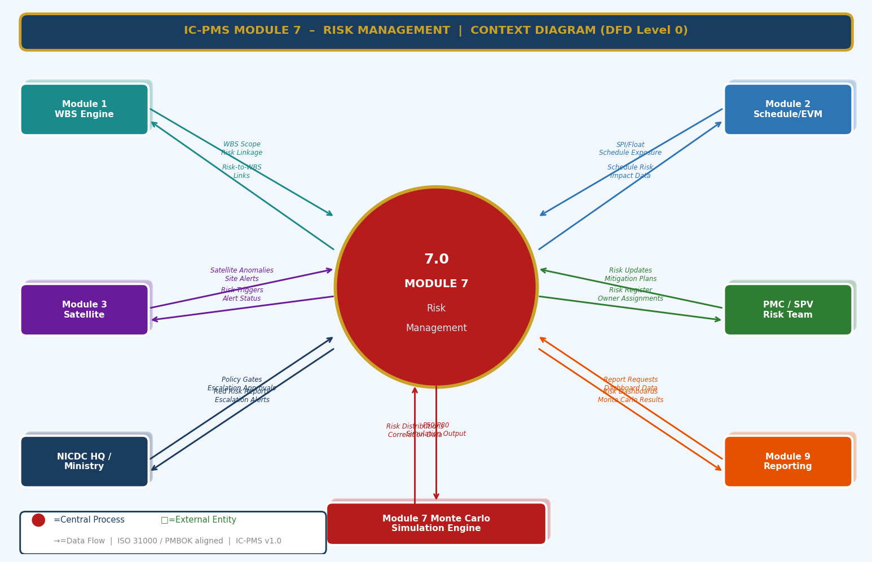
Figure 3.1 — DFD Level 0: Module 7 Context Diagram (Schedule, Satellite, Cost, PMC Inputs; MC Engine; NICDC/Ministry Escalations)

External Entity Data Flow Summary
External Entity | Inputs to Module 7 | Outputs from Module 7
Module 1 — WBS Engine | WBS scope hierarchy for risk linkage; Project phases for risk category relevance filtering | Risk-to-WBS links; risk count per WBS element for dashboard overlay
Module 2 — Schedule/EVM | SPI/CPI values per package; Total Float on critical activities; Data date for trigger checking | Schedule risk score adjustments; P80 schedule delay input to Module 2 look-ahead; CP risk flags
Module 3 — Satellite | Satellite anomaly alerts (encroachment, idle zone, NDVI excess); AI progress discrepancy flags | Risk triggers activated by satellite; risk records auto-created from satellite alerts
PMC / SPV Risk Team | New risk identification; qualitative assessment scores; response plan updates; monthly review decisions | Risk register with RED/AMBER/GREEN ratings; response action assignments; trigger alerts; MC P80 estimates
NICDC HQ / Ministry | Policy gates on escalated RED risks; escalation approval decisions | RED and Crimson risk escalation alerts; weekly flash reports; MC quarterly disclosure; programme heat map
Module 9 — Reporting | Report generation requests; distribution list | Monthly Risk Report PDF; Heat map visuals; Lessons Learned digest; MC Quarterly Report
Monte Carlo Engine (internal) | Risk distribution parameters; correlation matrix; schedule network from Module 2 | 10,000-iteration P50/P80 outputs; Tornado chart; S-curve for cost and schedule

3.2 DFD Level 1 — Main Processes & Data Stores
The Level 1 DFD shows eight core risk management processes and eight data stores spanning the full risk lifecycle — from identification through qualitative assessment, Monte Carlo quantification, response planning, monitoring, trigger escalation, opportunity tracking, and reporting.
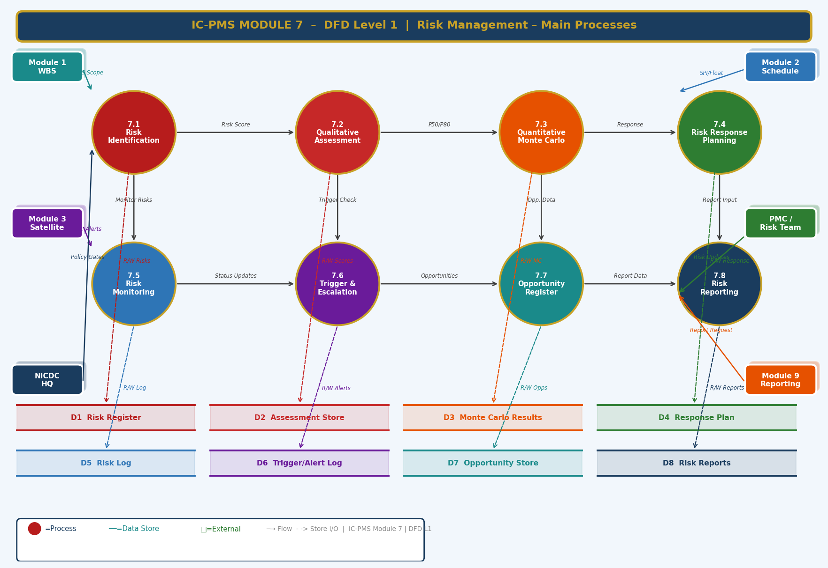
Figure 3.2 — DFD Level 1: Eight Core Processes and Eight Data Stores

Process and Data Store Descriptions
ID | Name | Primary Function | Key Stores
7.1 | Risk Identification | Captures new risks from multiple sources (workshops, checklists, Module 2/3/4/5 triggers, analogous projects) | D1 Risk Register
7.2 | Qualitative Assessment | Scores risk probability and impact on 5×5 matrix; computes risk rating (Crimson/Red/Amber/Green) | D1 Risk Register, D2 Assessment Store
7.3 | Quantitative Monte Carlo | Runs 10,000-iteration simulation; generates P50/P80 cost and schedule; produces Tornado sensitivity chart | D3 MC Results, D9 Distributions, D10 Correlations
7.4 | Risk Response Planning | Assigns Avoid/Transfer/Mitigate/Accept strategies; sets action owners and due dates; links contingency to Module 4 | D4 Response Plan
7.5 | Risk Monitoring & Review | Tracks risk status; updates scores from Module 2/3/4 data; refreshes MC monthly; identifies new risks | D5 Risk Log
7.6 | Trigger & Escalation | Monitors predefined triggers; fires escalation alerts; manages contingency plan activation; records near-misses | D6 Trigger/Alert Log
7.7 | Opportunity Register | Tracks positive risks; manages VE proposals; measures opportunity realisation rate | D7 Opportunity Store
7.8 | Risk Reporting | Auto-generates MRR, Weekly Flash, MC Quarterly, RED escalation reports; distributes via Module 9 | D8 Risk Reports

3.3 DFD Level 2 — Process 7.3: Monte Carlo Engine (Exploded)
The Level 2 DFD drills into the Monte Carlo Engine — the most computationally intensive and analytically sophisticated process in IC-PMS. Eight sub-processes cover the complete simulation pipeline from risk input extraction through distribution fitting, correlation matrix application, Latin Hypercube sampling, schedule and cost simulation, sensitivity analysis, and P50/P80 output with a convergence check decision diamond.
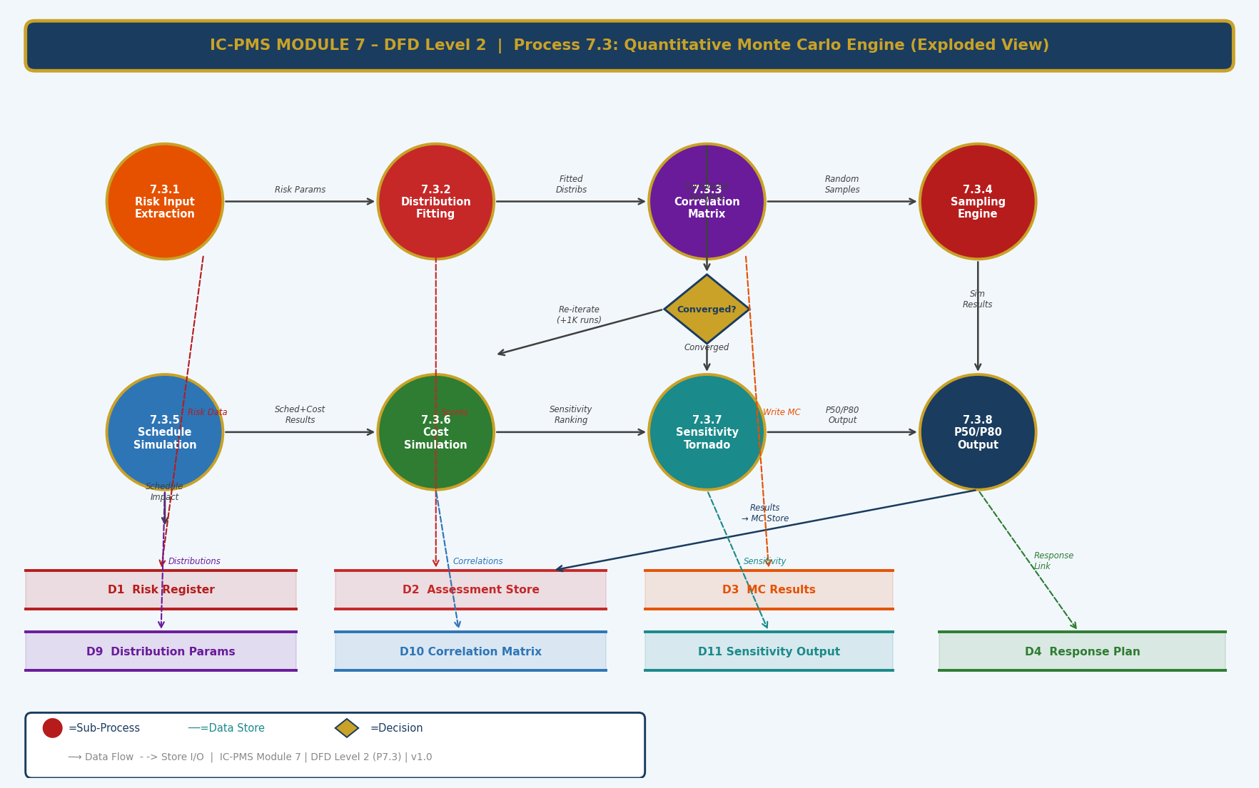
Figure 3.3 — DFD Level 2: Process 7.3 Monte Carlo Engine — 8 Sub-Processes with Convergence Decision Diamond

Sub-Process Narrative
Sub-Process | Name | Description
7.3.1 | Risk Input Extraction | Reads all AMBER and RED risks from D1 (Risk Register) and their three-point impact estimates (O, M, P) from D2 (Assessment Store). Validates completeness — risks without three-point estimates flagged for risk owner input before simulation can proceed.
7.3.2 | Distribution Fitting | Fits each risk's O, M, P estimates to an appropriate statistical distribution: PERT-Beta (default for symmetric risks), Triangular (for uniform uncertainty), Lognormal (for cost escalation risks with positive skew). Distribution parameters (alpha, beta, min, max) stored in D9.
7.3.3 | Correlation Matrix | Reads the expert-defined correlation coefficients between risk pairs from D10. Applies Cholesky decomposition to the correlation matrix to generate a valid covariance structure. Validates that the matrix is positive semi-definite; if not, applies nearest positive semi-definite correction automatically.
7.3.4 | Sampling Engine (LHS) | Executes Latin Hypercube Sampling: divides the probability range [0,1] into N equal strata (N = iterations / 10); samples once from each stratum per risk; shuffles samples to produce uncorrelated starting values; applies Iman-Conover method to impose the target correlation structure from the matrix.
7.3.5 | Schedule Simulation | For each of 10,000 iterations: applies sampled risk schedule impacts (in days) to the Module 2 CPM network. Re-runs CPM forward/backward pass. Records total project delay in days. Generates frequency histogram of 10,000 delay outcomes. P50 = median delay; P80 = 80th percentile delay.
7.3.6 | Cost Simulation | For each iteration: applies sampled risk cost impacts (in ₹ Cr) to the deterministic EAC from Module 4. Applies correlation structure so that high cost and high schedule outcomes co-occur for correlated risks. Records total cost outcome. P50 = median cost; P80 = 80th percentile cost. Contingency recommendation = P80 – deterministic EAC.
7.3.7 | Sensitivity Tornado | Computes Spearman rank correlation between each risk's 10,000 sampled values and the total cost outcome. Risks sorted descending by absolute correlation. Top 10 risks form the Tornado chart — visualising which risks contribute most to total uncertainty. Stored in D11 Sensitivity Output.
7.3.8 | P50/P80 Output & Convergence | Checks convergence: if P50 and P80 change < 0.5% over last 1,000 iterations → converged → write final results to D3 (MC Results). If not converged → run additional 5,000 iterations (decision diamond loops back to sampling). Maximum 3 extension batches (35,000 total iterations). Convergence metric and run timestamp stored.

4. Master Data Model

4.1 Entity Relationship Overview
The Module 7 master data model contains twelve entities. The Risk Register is the central entity; Risk Assessment, Monte Carlo Result, and Risk Response are its primary analytical outputs. The Risk Log, Trigger/Escalation Log, Sensitivity Record, and Lessons Learned provide the governance and institutional learning layer. Risk Category Master and Risk Matrix Config are the configuration entities that shape the entire risk management framework.
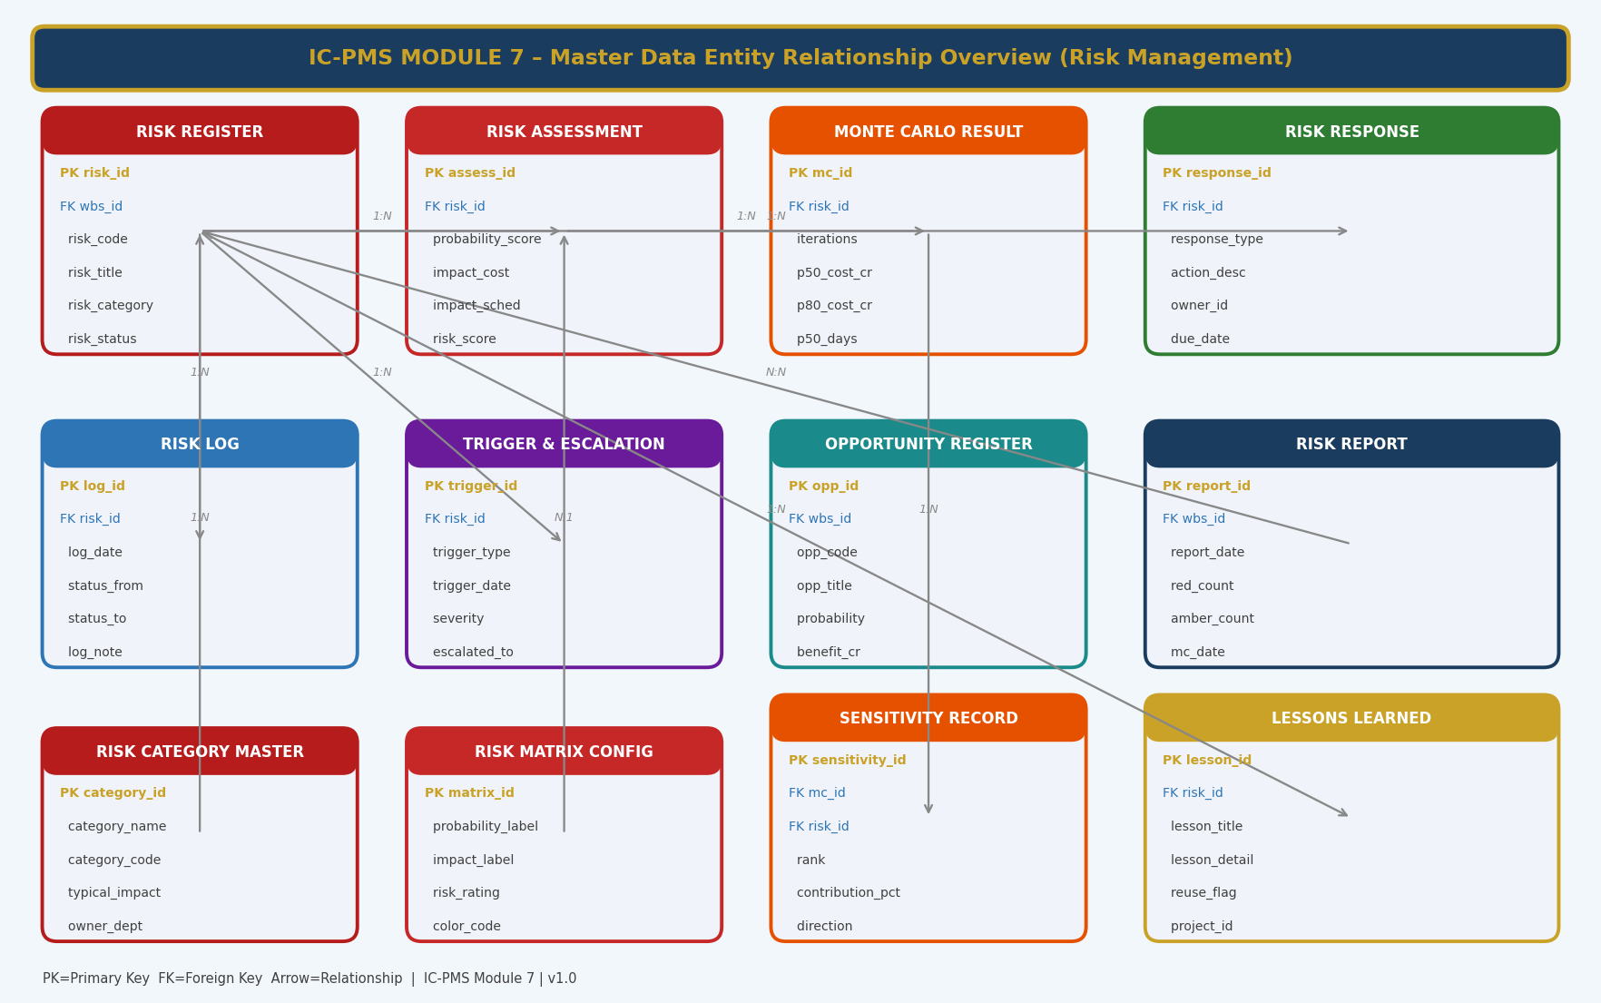
Figure 4.1 — Master Data Entity Relationship Overview (Module 7 — Risk Management)

4.2 Core Entity Field Definitions

4.2.1 Risk Register
risk_id | UUID — Primary Key
wbs_id | FK → Module 1 WBS Element — scope the risk belongs to
risk_code | VARCHAR — unique code (RISK-{Corridor}-{Seq}) e.g. RISK-DMIC-047
risk_title | VARCHAR — concise one-line risk title
risk_description | TEXT — full description of risk cause, event, and effect
risk_category_id | FK → Risk Category Master — one of 9 categories
probability_score | DECIMAL(3,2) — 0.0 to 1.0 probability
probability_rating | ENUM: Very_Low / Low / Medium / High / Very_High
impact_cost_cr | DECIMAL(15,2) — most likely cost impact in INR Crore
impact_schedule_days | INTEGER — most likely schedule impact in days
impact_rating | ENUM: Very_Low / Low / Medium / High / Very_High
risk_score | INTEGER — 1–25; computed: probability_rating × impact_rating
risk_rating | ENUM: Green / Amber / Red / Crimson
response_strategy | ENUM: Avoid / Transfer / Mitigate / Accept_Active / Accept_Passive / Exploit
risk_owner_id | FK → User — accountable for risk monitoring
action_owner_id | FK → User — responsible for executing response actions
risk_source | ENUM: Workshop / Checklist / Module2_Trigger / Module3_Trigger / Module4_Trigger / Module5_Trigger / Analogous
risk_status | ENUM: Draft / Active / Triggered / Mitigated / Closed / Transferred
created_date / last_reviewed | DATE — creation and most recent review dates

4.2.2 Risk Assessment (Quantitative Three-Point Estimates)
assess_id | UUID — Primary Key
risk_id | FK → Risk Register
assessment_date | DATE — when this assessment was conducted
probability_score | DECIMAL(3,2) — probability used in Monte Carlo (may differ from qualitative)
impact_cost_optimistic | DECIMAL(15,2) — O: best case cost impact (₹ Cr)
impact_cost_most_likely | DECIMAL(15,2) — M: most likely cost impact (₹ Cr)
impact_cost_pessimistic | DECIMAL(15,2) — P: worst case cost impact (₹ Cr)
impact_sched_optimistic | INTEGER — O: best case schedule impact (days)
impact_sched_most_likely | INTEGER — M: most likely schedule impact (days)
impact_sched_pessimistic | INTEGER — P: worst case schedule impact (days)
distribution_type | ENUM: PERT_Beta / Triangular / Lognormal / Uniform
risk_score | DECIMAL(5,2) — P × M_impact normalised to 0–25 scale
assessed_by | FK → User
is_current | BOOLEAN — true if this is the most recent assessment for the risk

4.2.3 Monte Carlo Result
mc_id | UUID — Primary Key
wbs_id | FK → WBS Element — scope of the simulation (project/node/corridor)
run_date | TIMESTAMP — when the simulation was executed
iterations | INTEGER — total iterations run (typically 10,000)
convergence_pct | DECIMAL(5,2) — convergence metric at final iteration
risks_included | INTEGER — count of AMBER+ risks included in simulation
p10_cost_cr | DECIMAL(15,2) — 10th percentile total cost (₹ Cr)
p50_cost_cr | DECIMAL(15,2) — 50th percentile total cost (₹ Cr)
p80_cost_cr | DECIMAL(15,2) — 80th percentile total cost (₹ Cr)
p90_cost_cr | DECIMAL(15,2) — 90th percentile total cost (₹ Cr)
deterministic_eac_cr | DECIMAL(15,2) — EAC from Module 4 at run date
contingency_rec_cr | DECIMAL(15,2) — recommended contingency = p80_cost_cr – deterministic_eac_cr
p50_sched_days | INTEGER — 50th percentile schedule delay (days)
p80_sched_days | INTEGER — 80th percentile schedule delay (days)
mean_cost_cr / std_dev_cr | DECIMAL — statistical mean and standard deviation of cost outcomes

4.2.4 Risk Response
response_id | UUID — Primary Key
risk_id | FK → Risk Register
response_type | ENUM: Avoid / Transfer / Mitigate / Accept_Active / Accept_Passive / Exploit
action_description | TEXT — specific action to be taken
action_owner_id | FK → User — person responsible for executing the action
due_date | DATE — target completion date for the action
expected_prob_reduction | DECIMAL(3,2) — expected reduction in probability if action is executed (0.0 to 1.0)
expected_cost_reduction_cr | DECIMAL(15,2) — expected reduction in cost impact (₹ Cr)
expected_sched_reduction_days | INTEGER — expected reduction in schedule impact (days)
residual_risk_score | INTEGER — expected risk score after response (1–25)
contingency_budget_cr | DECIMAL(15,2) — for Accept Active: contingency provision exported to Module 4
action_status | ENUM: Planned / In_Progress / Completed / Deferred / Ineffective
effectiveness_score | INTEGER 1–5 — monthly effectiveness rating by risk owner
secondary_risk_id | FK → Risk Register — if response creates a secondary risk

4.2.5 Trigger & Escalation Log
trigger_id | UUID — Primary Key
risk_id | FK → Risk Register
trigger_type | ENUM: Manual / Module2_SPI / Module2_Float / Module3_Satellite / Module3_NDVI / Module4_CPI / Module4_VO / Module5_Scorecard
trigger_description | TEXT — description of the specific trigger condition breached
trigger_date | TIMESTAMP — when the trigger was detected
trigger_severity | ENUM: Watch / Warning / Alert / Emergency
source_data_value | VARCHAR — the specific value that breached the threshold (e.g. 'SPI = 0.82')
escalated_to_user_id | FK → User — who was notified
escalation_date | TIMESTAMP — when escalation notification was sent
acknowledgement_date | TIMESTAMP — when risk owner acknowledged; NULL if pending
contingency_activated | BOOLEAN — true if contingency plan was activated
resolution_notes | TEXT — how the trigger was resolved
resolved_date | DATE

4.2.6 Lessons Learned
lesson_id | UUID — Primary Key
risk_id | FK → Risk Register — the closed risk this lesson derives from
lesson_title | VARCHAR — concise lesson title
lesson_detail | TEXT — full description: what happened, why, what was the response, what would be done differently
risk_category | FK → Risk Category Master — category for future filtering
applicable_corridors | VARCHAR — which other corridors should note this lesson
reuse_flag | BOOLEAN — true if lesson has been used in another project
lesson_type | ENUM: Process / Technical / Commercial / Stakeholder / Environmental
impact_if_applied | TEXT — expected benefit if lesson is applied to future projects
submitted_by | FK → User
approved_by | FK → User — PMC Risk Lead / NICDC PMO
project_id | FK → Module 1 Project Master — the project this lesson came from

5. UI/UX Screen Designs
Module 7 delivers five primary screens. The module uses crimson (#B71C1C) as its identity colour — evoking urgency and the importance of risk vigilance. The design philosophy for Module 7 is 'surfacing what matters' — RED and Crimson risks are immediately visible on every screen, the Monte Carlo S-curve is available in two clicks from anywhere, and risk owners have no ambiguity about what actions are required of them and by when.

Screen 1 — Risk Management Dashboard
The Dashboard is the programme-level risk status overview — designed for NICDC Programme Directors and SPV Directors to get an instant, colour-coded picture of where the risks are and whether they are getting better or worse. The 5×5 heat map, RED risk list, and 6-month trend chart are the three most important elements.
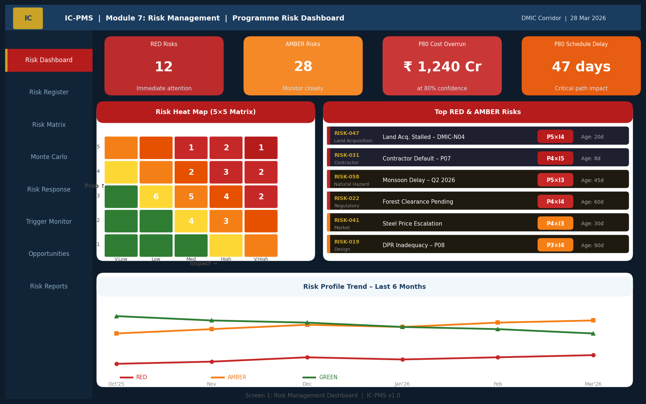
Figure 5.1 — Risk Dashboard (KPI Cards, 5×5 Heat Map with Risk Counts, Top RED Risks, 6-Month Trend Chart)

Dashboard UI Components
Component | Description | Interaction
KPI Cards (4 — top row) | RED Risks count, AMBER Risks count, P80 Cost Overrun (₹ Cr from MC), P80 Schedule Delay (days from MC). Colour-coded: crimson for RED, amber for AMBER. | Click RED/AMBER cards to open Risk Register filtered to that rating; click MC cards to open Monte Carlo screen
5×5 Heat Map (left) | Interactive probability-impact matrix with risk count per cell. Cells colour-coded: deep red = top-right (critical), green = bottom-left (low). Risk count shown as large number in each cell. | Click any cell to see the list of risks in that cell; hover for cell definition (e.g. 'P4×I4 = 16: High Risk')
Top RED Risks List (right) | 6 highest-priority RED/Crimson risks with: Risk ID, title, category, P×I score badge, owner, age in days, trend arrow | Click any risk row to open Risk Detail screen (Screen 4); trend arrow (↑/↓/→) shows whether risk is worsening, improving, or stable this month
6-Month Risk Trend (bottom) | Line chart showing count of RED, AMBER, GREEN risks each month. Rising RED line = programme risk is increasing. | Hover for monthly counts; click month to see snapshot of risk register at that date (historical view)

Screen 2 — Risk Register
The Risk Register is the operational view of all risks — a sortable, filterable, paginated table of every risk in the programme with all key attributes visible at a glance. This is the screen PMC Risk Leads work in daily — updating assessments, tracking response progress, and managing the risk review cycle.
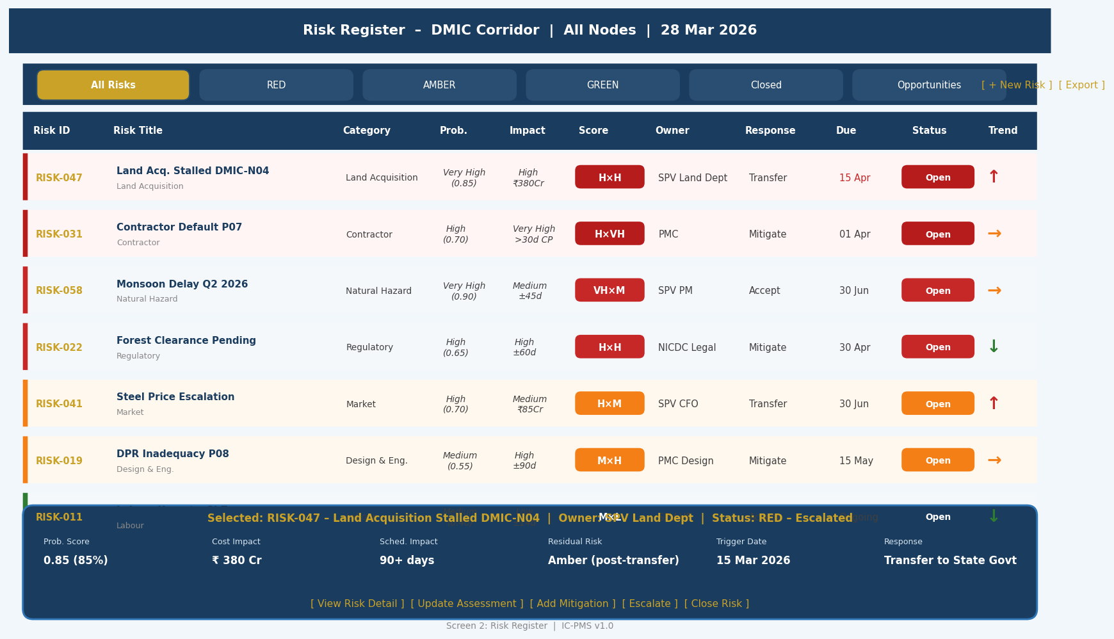
Figure 5.2 — Risk Register (Status Filter Tabs, Risk Rows with RAG Stripe, Trend Arrows, Detail Panel)

Risk Register Screen Design
- Coloured left stripe: Each risk row has a coloured left stripe (crimson/red/amber/green) — the single most important visual signal; row colour tone reinforces priority
- Trend arrow column: An ↑ (red), → (amber), or ↓ (green) arrow in the final column shows month-over-month risk score direction — instantly reveals which risks are deteriorating
- Filter tabs: Six tabs (All / RED / AMBER / GREEN / Closed / Opportunities) with count badges; single-click to view just the risks in that rating band
- Inline score display: P×I score shown as a coloured badge — no need to open the risk to see its rating; P (probability) and Impact shown as fraction notation (e.g. P4×I3) for immediate comprehension
- Selected risk detail panel: Fixed at the bottom of the screen — loads on row click without navigating away; shows all quantitative details and quick-action buttons (Escalate, Update, Close)
- Sort by multiple columns: Sort by risk score (default), age, owner, due date, category — enables different management views of the same data

Screen 3 — Monte Carlo Simulation Results
The Monte Carlo screen is the most analytically rich screen in Module 7 — presenting the P50/P80 cost and schedule S-curves, the Tornado sensitivity chart, and a statistical summary table. It is used primarily by NICDC Finance, lenders, and Ministry officials making contingency and budget provision decisions.
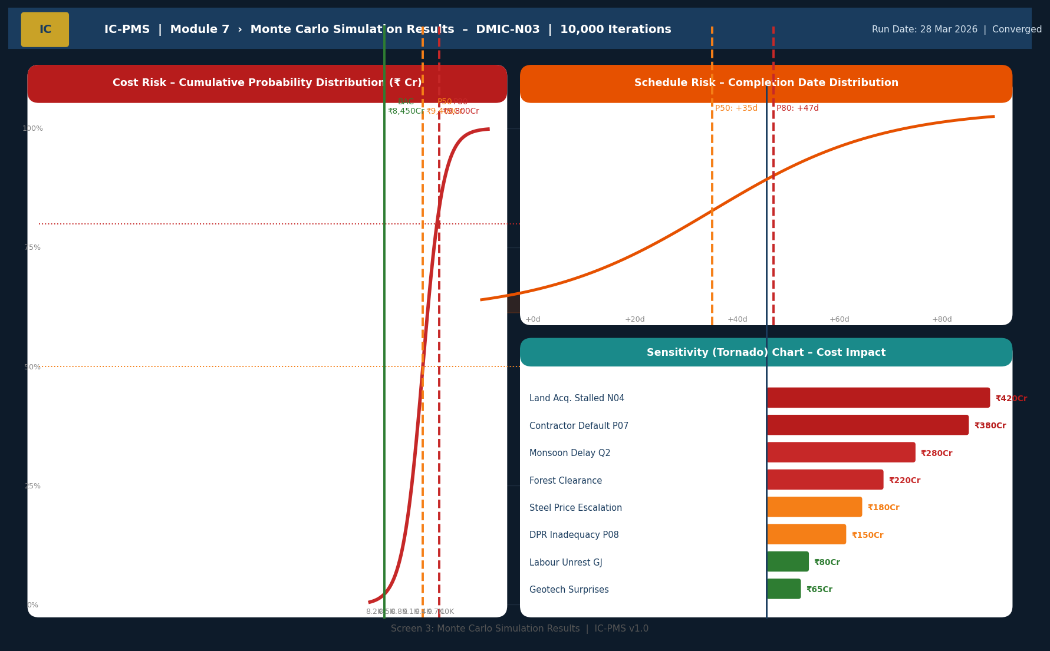
Figure 5.3 — Monte Carlo Results (Cost S-Curve with P50/P80/BAC, Schedule Distribution, Tornado Sensitivity Chart)

Monte Carlo Screen Components
Component | Description | Key User Value
Cost S-Curve (left panel) | Cumulative probability distribution of total project cost. X-axis = cost (₹ Cr); Y-axis = cumulative probability (0–100%). BAC line (green), P50 (amber dashed), P80 (red dashed) marked. Filled area under curve shows risk exposure. | Answers 'What is the probability we finish within budget?' — BAC is below P50, meaning more than 50% chance of overrun
Schedule Distribution (top right) | S-curve for schedule delay (days beyond planned completion). P50 = +35 days, P80 = +47 days shown. | Answers 'How likely is delay and how much?' — critical for lender milestone covenant negotiations
Tornado Chart (bottom right) | Horizontal bar chart of top 8 risks ranked by contribution to cost uncertainty (Spearman rank correlation × max cost impact). Longer bar = more influence on outcome. | Answers 'Which risks should we spend money mitigating?' — prioritises response investment objectively
Run controls | Run New Simulation button, iteration count selector (5K/10K/20K), scope selector (Node/Corridor/Programme) | Run on-demand with updated risk data; higher iterations for more precise P-values

Screen 4 — Risk Detail & Response Plan
The Risk Detail screen provides a complete, single-risk deep-dive — showing the full description, impact analysis, trigger conditions, and all response actions in a two-panel layout. It is the screen used during the monthly risk review meeting when a risk owner must present the current status and planned actions.
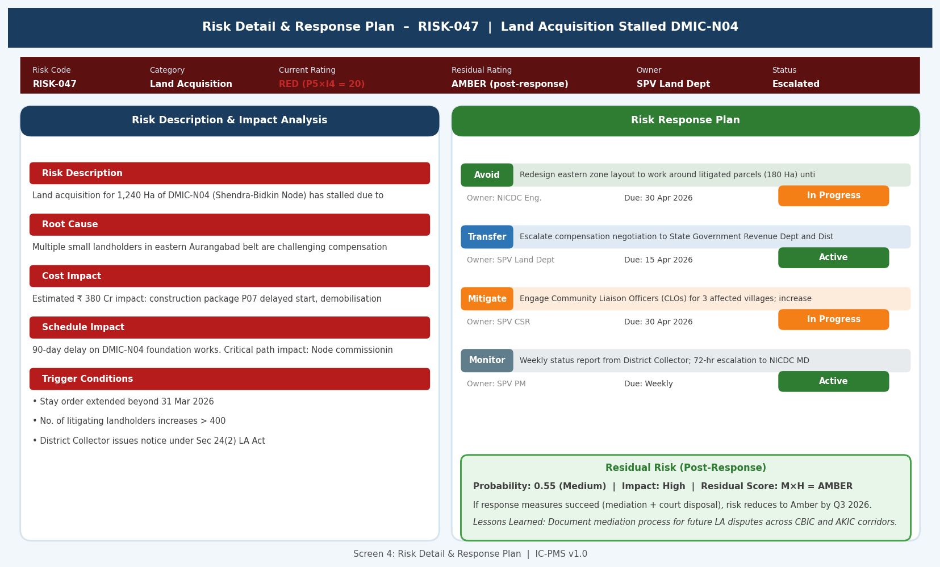
Figure 5.4 — Risk Detail & Response Plan (Risk Narrative, Impact Analysis, Response Action Cards, Residual Risk)

Risk Detail Screen Design
- Risk header strip: Critical metadata always visible at top — risk code, category, current rating badge, residual rating, owner, status — providing context for all detail below
- Narrative sections (left): Five collapsible sections (Description, Root Cause, Cost Impact, Schedule Impact, Trigger Conditions) — long text is readable without scrolling due to collapsible structure
- Response action cards (right): Each response strategy shown as a distinct card with action text, owner badge, due date, and status indicator — multiple strategies visible simultaneously
- Residual risk box: Clearly distinguished green section at the bottom right showing the expected risk profile AFTER all response actions are executed — the 'target state'
- Lessons Learned link: Automatically shows any related lessons from previous projects in the same risk category — enabling risk owners to learn from history
- Quick actions bar: At the bottom — Update Assessment, Add Response Action, Escalate, Raise Near-Miss, Close Risk — all primary actions accessible without navigating away

Screen 5 — Risk Exposure Analytics
The Analytics screen provides programme-level risk aggregation views: risk distribution by category, risk profile by corridor node, Monte Carlo summary statistics, and the P80 cost overrun trend chart. It is designed for NICDC Programme Directors conducting programme-level risk reviews and preparing Ministry briefings.
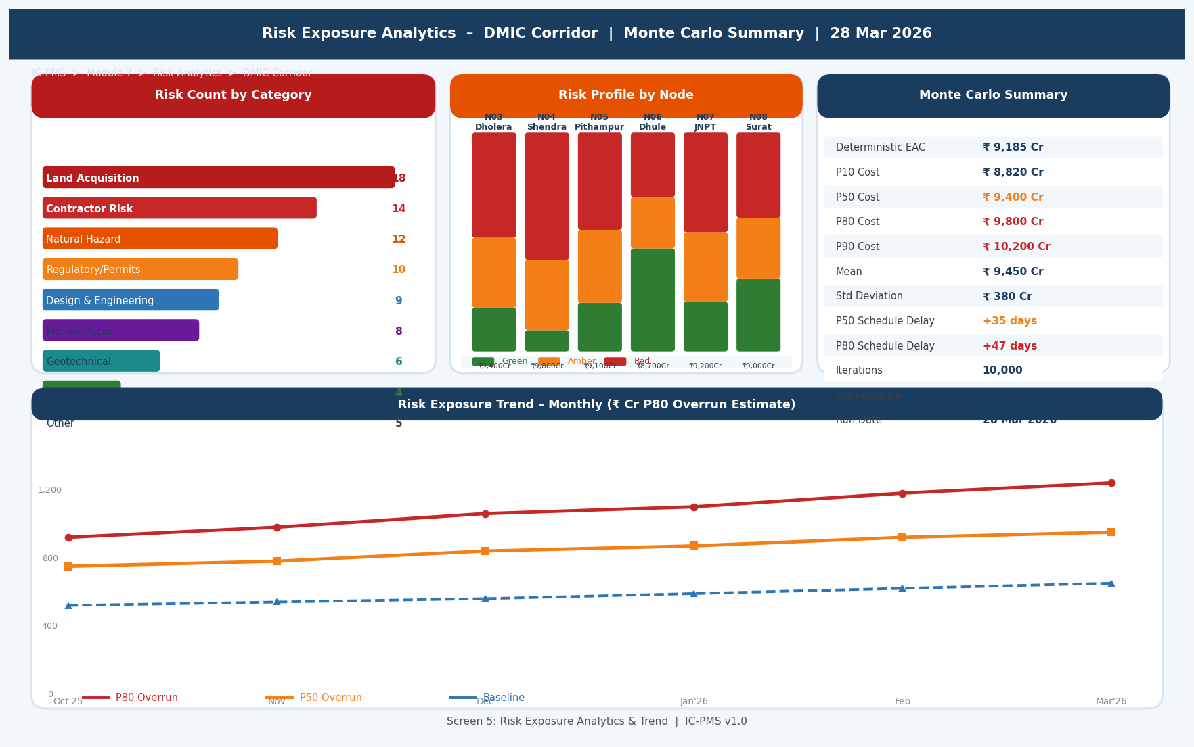
Figure 5.5 — Risk Exposure Analytics (Category Distribution, Node Risk Profile, MC Summary, P80 Trend Chart)

Analytics Screen Components
Component | Description
Risk by Category (left) | Horizontal bar chart showing risk count per category, colour-coded by category severity. Instantly shows which categories dominate the risk profile (Land Acquisition and Contractor Risk typically lead for industrial corridors).
Risk Profile by Node (centre) | Stacked bar chart per node showing Green/Amber/Red count proportions and total EAC (₹ Cr). Nodes with high RED stack are visually prominent — immediate escalation priorities.
Monte Carlo Summary Table (right) | Clean tabular summary of the last simulation run: P10/P50/P80/P90 cost, deterministic EAC, mean, std deviation, P50/P80 schedule delay, iterations, convergence. Quick reference for Ministry briefings.
P80 Overrun Trend (bottom full-width) | 6-month line chart showing P80, P50, and Baseline (deterministic) cost overrun estimates. Rising trend = risk exposure increasing. Shaded bands between P80 and P50 (red) and P50 and Baseline (amber) show risk zones. The most important single chart for programme financial risk communication.

6. Business Rules & Validation Logic

6.1 Risk Registration Rules
Rule ID | Description | Outcome
RSK-001 | Every risk must have an owner assigned before it can move from Draft to Active status | Blocking: 'Risk Owner is mandatory. Assign an owner from the OBS before activating this risk.'
RSK-002 | All RED (score ≥ 12) risks must have at least one non-Accept response strategy defined within 14 days of activation | Alert at day 7; blocking on day 14: 'A response plan is required for RED risks within 14 days of identification.'
RSK-003 | All AMBER and RED risks must have three-point estimates (O, M, P) for cost and schedule impact before Monte Carlo can include them | MC simulation ignores risks without three-point estimates; warning shown on MC results screen listing excluded risks
RSK-004 | A risk can only be Closed if: all response actions are marked Complete, no active triggers, and the risk owner and PMC Risk Lead both approve closure | Dual-approval workflow for risk closure; system prevents premature closure of RED risks
RSK-005 | Risk scores are automatically recalculated weekly based on Module 2/3/4 data; manual override of system-generated scores requires PMC Risk Lead approval with justification | Audit trail records all manual overrides; pattern of overrides flagged to NICDC for governance review

6.2 Monte Carlo Rules
Rule ID | Description | Outcome
MC-001 | Monte Carlo simulation must be re-run at least monthly; if simulation has not been run in > 35 days, P50/P80 values on dashboards are flagged as stale | Warning banner: 'Monte Carlo results are 36 days old. Re-run recommended before monthly reporting.'
MC-002 | If P80 cost estimate increases by > ₹ 100 Cr between consecutive monthly simulations, automatic alert to NICDC Finance Director | Alert email with before/after comparison; Tornado chart showing which risk drove the increase
MC-003 | Monte Carlo results are not published to external reports (Ministry, lenders) without NICDC Programme Director approval | Approval workflow: MC results generated → PMC Risk Lead reviews → NICDC PD approves → published to Module 9
MC-004 | Correlation matrix must be reviewed and updated at least quarterly; default correlation values auto-populated from NICDC standard template if not manually set | Warning if correlation matrix not reviewed in > 90 days; default correlations used with disclosure in report

6.3 Escalation Rules
Rule ID | Description | Outcome
ESC-001 | A Crimson risk (score 25 — Very High × Very High) triggers immediate NICDC MD notification within 4 hours of identification | System auto-sends alert; if NICDC MD does not acknowledge within 8 hours, Ministry is copied
ESC-002 | A RED risk (score 12–24) not acknowledged by risk owner within 24 hours of trigger escalates to the risk owner's supervisor | Escalation chain defined in OBS; automatic after 24-hour SLA breach
ESC-003 | Any RED risk unresolved (remaining RED) for > 60 days requires a formal Position Paper submitted to NICDC MD | System generates Position Paper template at day 55 alert; blocking if not submitted by day 60
ESC-004 | A risk trigger from Module 3 (satellite) must generate a risk record within 5 working days if the anomaly is not resolved | Orphaned satellite alerts (unlinked to risk register) flagged in weekly dashboard; DMS admin notified

7. Integration Touchpoints

7.1 Internal Module Integrations
Module | Data Exchanged | Trigger / Frequency
Module 1 — WBS | Inbound: WBS hierarchy for risk-to-scope linkage, project phases for risk category relevance; Outbound: Risk count per WBS element for Module 1 dashboard overlay | On WBS Publish; daily refresh of risk count per WBS
Module 2 — Schedule/EVM | Inbound: SPI/CPI per package, Total Float per CP activity, Data date; Outbound: P80 schedule delay added to look-ahead planning horizon; risk flags on CP activities | Daily data pull for trigger monitoring; monthly for MC input refresh
Module 3 — Satellite | Inbound: Encroachment alerts, idle zone flags, NDVI excess alerts → auto-create risk triggers; Outbound: Risk heat overlay for satellite map (Module 3 GIS viewer shows risk colour per WBS polygon) | Weekly satellite processing cycle; real-time for Critical encroachment alerts
Module 4 — Cost Management | Inbound: CPI per package, VO % of LOA (for scope creep risk); deterministic EAC for MC baseline; Outbound: Contingency reserve recommendation (P80 – EAC) for budget node; risk-linked contingency provisions | Monthly data date advance; contingency on demand per MC run
Module 5 — Contract Management | Inbound: Contractor performance scorecard (for contractor default risk triggers); VO accumulation alerts; Outbound: Risk score for contractor as input to payment approval decision | Monthly scorecard publication; real-time VO limit breach
Module 6 — DMS | Outbound: Monthly Risk Reports, MC Quarterly Reports, RED escalation documents auto-filed in DMS under relevant WBS risk folder | On each report generation event
Module 9 — Reporting | Outbound: Risk heat map data, top 10 risks, P80 summary for executive dashboards and MPR; risk count by node for programme dashboard | Real-time API read; daily refresh

7.2 External System Integrations
System | Integration | Data Flow | Notes
Oracle Primavera Risk Analysis | XER/XML bidirectional | Risk data exported to Primavera Risk Analysis format for clients using that tool; results imported back | On-demand export; XER format compatible with PRisk 8.7+
RBI / IMD (Weather data) | REST API — read | Monsoon onset/withdrawal dates and intensity data ingested to update probability of natural hazard risks seasonally | Monthly IMD seasonal forecast; real-time cyclone alert API
MoEFCC PARIVESH | REST API — read | Environmental clearance status polled to update probability of EC-related regulatory risks | Weekly status check; auto-updates risk probability if clearance granted
Land Records (DILRMS) | REST API — read | LA parcel acquisition status (acquired/litigated/pending) used to update Land Acquisition risk probability and trigger thresholds | Weekly status refresh from DILRMS API
NICDC Lessons Learned DB | REST API — bidirectional | Historical risk data from completed NHAI/NMRC/NICDC projects available as analogous risk import; closed lessons pushed to NICDC PMO database | On-demand import; quarterly lessons export

8. Workflow & Approval Chains

8.1 Risk Lifecycle Workflow
State | Entry Condition | Permitted Actions | Exit to Next State
Draft | Risk identified by any team member | Edit all fields; assign owner | PMC Risk Lead submits after basic validation
Active | PMC Risk Lead validates and activates | Full assessment; response planning; trigger definition | Monthly reviews continue until risk resolves or triggers
Triggered | Trigger condition breached (manual or auto) | Contingency plan activation; response escalation; near-miss record | Risk resolves → Mitigated; risk materialises → Loss Event
Mitigated | All response actions complete; risk score reduced to Green | Verify residual risk; approve closure | PMC Risk Lead + Risk Owner dual-approve closure
Closed | Risk no longer applicable; response effective | Lessons learned capture; archive | Terminal — 30-year retention
Transferred | Risk contractually transferred to third party (insurer/contractor) | Monitor transfer mechanism; track insurance policy expiry | Closure on project completion or transfer period end

8.2 Risk Escalation Approval Chain
Risk Rating | First Escalation | Second Escalation | Third Escalation | Review Frequency
Green | SPV PM — quarterly | — | — | Quarterly risk review
Amber | PMC Risk Lead — monthly | SPV Director if unresolved 30 days | — | Monthly risk workshop
Red | SPV Director — weekly | NICDC Programme Director if unresolved 14 days | — | Weekly 1:1 with PMC Risk Lead
Crimson (score 25) | NICDC MD — within 4 hours | Ministry Secretary if unresolved 7 days | CCEA briefing if unresolved 30 days | Daily situation report to NICDC MD

9. Performance & Non-Functional Requirements
Requirement | Specification | Measurement
Monte Carlo run time | 10,000 iterations for a 50-risk model < 5 minutes on NIC MeghRaj GPU cluster | Job completion time log; alert if > 15 minutes
Risk register load | < 2 seconds to load full risk register (up to 500 risks) with all metadata | Lighthouse P95; tested with 500 risk records
Heat map render | < 1 second to render 5×5 heat map with risk counts populated | Frontend render time
Trigger check latency | < 30 minutes from Module 2/3/4 data update to trigger alert generation | Trigger monitoring pipeline job completion time
Escalation notification delivery | < 5 minutes from trigger breach to email/SMS notification | End-to-end notification latency log
Concurrent risk review users | 100 simultaneous users during monthly risk workshop without degradation | k6 load test at 100 VUs
Monte Carlo result storage | All 10,000 iteration results stored for audit; queryable by P-value | Elasticsearch + NIC MeghRaj object storage
Risk data retention | 30 years — all risk records, assessment history, MC results, trigger logs | GFR 2017 / National Archives compliance
System uptime (risk module) | 99% — risk monitoring is a safety-critical function; downtime could mask emerging risks | Synthetic monitoring; monthly SLA report
Mobile risk entry | Risk capture via mobile app < 3 minutes for a new risk record (voice-to-text assisted) | Mobile PWA field testing on Android/iOS

10. Glossary — Module 7 Terms
Term | Definition
Risk | An uncertain event or condition that, if it occurs, has a positive or negative effect on one or more project objectives (ISO 31000)
Threat | A risk with a negative effect on project objectives — cost increase, schedule delay, quality reduction, or reputational damage
Opportunity | A risk with a positive effect on project objectives — cost saving, schedule acceleration, or enhanced deliverable quality
Probability | The likelihood that a risk event will occur, expressed as a fraction (0.0–1.0) or qualitative rating (Very Low to Very High)
Impact | The consequence of a risk event, measured in cost (₹ Cr) and/or schedule (days) — may also include quality, reputational, environmental dimensions
Risk Score | Probability × Impact (normalised to a 1–25 scale from the 5×5 matrix); used for prioritisation
Monte Carlo Simulation | A computational technique that runs thousands of iterations using random samples from probability distributions to produce a range of possible project outcomes
P50 | The 50th percentile of the Monte Carlo distribution — there is a 50% probability that the actual outcome will be at or below this value
P80 | The 80th percentile — there is an 80% probability that the actual outcome will be at or below this value; recommended basis for contingency planning
Latin Hypercube Sampling (LHS) | A statistical sampling method that divides the probability range into equal strata and samples once from each — more efficient convergence than pure random Monte Carlo
Tornado Chart | A sensitivity analysis chart showing which risks contribute most to total project uncertainty; risks shown as horizontal bars ranked by their correlation with total outcome
Trigger | A specific, observable event that signals a risk is becoming active or is about to materialise
Residual Risk | The level of risk remaining after response measures have been applied — the 'after' picture in the risk assessment
Risk Breakdown Structure (RBS) | A hierarchical framework for categorising risks by type — analogous to the WBS for scope; Module 7 uses a 9-category, India-specific RBS
Contingency Reserve | Budget allocated to cover the expected impact of identified risks; based on P80 MC estimate minus deterministic EAC
Management Reserve | Budget held by NICDC for unknown-unknown risks (Black Swan events) — not in the MC model; separate from contingency reserve
Cholesky Decomposition | Mathematical technique used to generate correlated random samples from a correlation matrix — ensures that related risks in the MC simulation occur together realistically
PERT Distribution | A weighted Beta distribution using three-point estimates (O, M, P) where the Most Likely is weighted 4× — used as default in Module 7 MC simulation
Near-Miss | An event that almost caused a risk to trigger but did not — recorded for institutional learning to identify systemic vulnerabilities
Lessons Learned | Documented knowledge from a closed risk — what happened, why, what response was effective, what would be done differently — reused across future projects

